Shabbos Stories For parshas ha’azinu 5785
Volume 16, Issue 2 3 Tishrei 5785/October 5, 2024
Printed L’illuy nishmas Nechama bas R’ Noach, a”h
For a free subscription, please forward your request to keren18@juno.com
Past emails can be found on the website – ShabbosStories.com
A Blast from the Past (Published August 31, 2001)
A Plane, a Boat
and a Haftorah
By Steve Hyatt

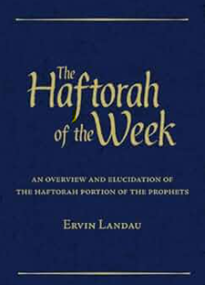

The flight to Philadelphia had barely cleared the runway in Portland when I took out my book, put on my headphones and played the tape Rabbi Choni Vogel had sent me to help me study for my haftorah. I couldn't help but smile as I heard his first few words, "Okay Shloma Yakov, here is the tape, I am sure you are going to be FANTASTIC!"
Fantastic indeed. I had been studying for six months and no matter how much I tried, I simply could not retain the melodies. Six months before, I had made a mitzva pledge to chant the haftora that I should have presented at my bar mitzva 33 years earlier. Back then, I was such a poor Hebrew school student that my teacher Rabbi Lapidus had wisely limited my role to a morning aliya and leading the afternoon service later that day. And even that had been an enormous challenge.

Trying to Find an Excuse
to Get Me Off the Hook
Of course, life had changed since I discovered Chabad, and reciting the haftorah of my youth had seemed like a great idea. But now it was almost "game time" and I simply was not ready. Even as I was practicing on the plane, I was trying to find an excuse to get me off the hook. I was desperate to avoid looking foolish in front of friends and family.
As I sat in my seat wallowing in self-doubt an elderly woman strolled past, looked at my open book with the Hebrew writing, looked at me and then kept walking. Repeating this procedure for the better part of a half hour, she finally stopped in front of me. She said, "It isn't often you see someone reading from a Hebrew book on an airplane. What are you reading?" I explained that I was practicing for my haftorah.
She smiled and sat down in the seat next to mine and proceeded to tell me her life story. She was a retired Jewish doctor living in Los Angeles and she and her husband were on their way to Philadelphia to see their son. After a little while she walked back to her seat.
Her Husband Gave Me an
Old Newspaper Article to Read
Several minutes later her husband sat down next to me. He pulled an old newspaper article from his jacket pocket and gave it to me to read. He explained that the photo in the article was of his cousin's school class back in Hungary during World War II. He pointed to his cousin and said he was the only member of the class that had escaped when the Nazis invaded his village. He thought since I was studying for my haftorah I would appreciate reading the article.
The story moved me but I was mystified why he thought it had a connection to my haftorah. When the plane landed, the doctor and her husband said goodbye.
After picking up my luggage, I started driving toward Chabad of Delaware, where Rabbi Vogel's second son Areleh was soon to celebrate his Bar Mitzva. As I crossed the state line into Delaware I could almost smell the aroma of the Rebbetzin's mouth-watering kugel cooking in the oven!
The next evening was Shabbat and it got off to a joyous start as friends and family from around the world prayed, ate, laughed and sang together. On Shabbat morning, Areleh made us all proud leading the services, reading from the Torah and chanting a magnificent haftorah.
When services were over the celebration began in earnest. After more food, and of course more kugel than I could eat, a full-fledged "farbrengen" began. Each participant shared insights and wisdom about the Torah portion, the responsibilities a boy assumes upon becoming Bar Mitzva and discussions of spirituality and commitment.

Recalling a Miraculous Escape from
the Nazis on the Last Boat Out of Calais
Midway through the festivities Rabbi Vogel cajoled his father, Reb Noson Vogel, to recount his miraculous escape from the Nazis, on the last boat out of Calais, France. Rabbi Vogel described how, on that fateful day, which "coincidentally" was exactly 61 years to the day of Areleh's Bar Mitzva, his sister had convinced a guard to let the family secretly scale the wall of the ship and board before it sailed out of port. In the end they were four of the less than seven hundred souls who finally escaped from the clutches of Hitler's henchmen that day.
He explained that only through G-d's blessing did he and his family escape the hands of the Nazis and how he had dedicated his life to foiling Hitler's ultimate plan by promoting and supporting Jewish education throughout the world. Rabbi Vogel established the Lubavitch Boys High School and eventually the Lubavitch Yeshiva in London, which sends to communities around the world hundreds of boys who are involved in Jewish outreach. He said that with every mitzva performed, and with every Jewish boy or girl educated, we ensure that the Jewish people survive and thrive in the post Hitler world.

Realized that Learning the Haftorah
was More Important than I Had Imagined
When Shabbat was over and it was time to return to Oregon, I returned with a passion burning in my heart. When I first started this journey I was fearful of "looking foolish" in front of my friends. After meeting the couple on the plane and then listening to Reb Vogel's words of inspiration, I realized that learning and chanting the haftorah was more important than I had ever imagined.
I realized that no matter the final melodic quality of my haftorah, it was imperative to complete it. For every note of my haftorah and the millions that others have and will chant, serve to remind us that despite the evil intent of the Hamens and the Hitlers of history, the spirit of the Jewish people still burns brightly throughout the world.
As I sat back in my seat I couldn't help but marvel at hearing two such painful, yet inspiring stories over the course of a few days.
I thanked G-d for these wondrous blessings, smiled, picked up my book, slapped on my headphones and went back to work.

Reprinted from the August 31, 2001 edition of L’Chaim Weekly, a publication of the Lubavitch Youth Organization.
Hashem Can Overcome a Seemingly Impossible Impasse
By Rabbi David Ashear

Rabbi Green* is a public speaker who is noted for giving chizuk to large crowds. He had an eligible daughter for whom he was seeking a shidduch. After doing much research, he zeroed in on Sruly,* a top boy in a top yeshivah, and inquired if he would be interested in meeting his daughter. Although Sruly and his parents found out wonderful information about the young lady, he declined to meet her.
“What’s the problem?” his parents asked.

Wants More from a Father-in-Law than
Some Who Gives Nice Chizak Speeches
“I heard that her father gives nice chizuk speeches, but I want a father-in-law to whom I can speak in learning, someone who is intimately familiar with the deep sugyos of Shas.”
Since Sruly had only recently begun dating, his parents did not pressure him to go out with this girl. A few months later, the same shidduch was suggested and again he turned it down.
Rabbi Green was invited to speak to the congregants of Mishkenos Yaakov on a Friday night after Kabbalas Shabbos. He replied that he lived far from the shul and it would be too difficult to walk home afterward. Hours later, having reconsidered, he called back. “Hashem has been so kind to me,” he said. “Now I have a chance to inspire His children to get closer to Him. How could I give up that chance because of a long walk?”
They arranged a date one month away. The Sunday before Rabbi Green’s speaking engagement was the day his daughter was suggested to Sruly for the second time. The next night, Sruly met his uncle at a wedding.
“What are your Shabbos plans?” his uncle asked. Sruly replied, “In yeshivah, as always.”

An Invitation to Come for a Shabbos Meal
“Why don’t you come to us for the Leil Shabbos seudah?” Sruly gladly accepted. The Mishkenos Yaakov shul is where the uncle davens, and Sruly went to shul with him that night. After Kabbalas Shabbos, the guest speaker, Rabbi Green, gave a speech that blew the crowd away.
“Who was that speaker?” Sruly asked his uncle as they walked home together after Maariv. “He was incredible!” When he heard the name, he was stunned. It was the father of the girl who had already been suggested to him twice! He realized he would be privileged to have a father-in-law like that.
On Motzei Shabbos, he told his parents he wanted to meet Rabbi Green’s daughter. A few weeks later, they were engaged. Sruly’s preference had been blocking him from meeting his destined wife. Hashem brought him and Rabbi Green to the same shul at the same time – a shul neither of them ever davened in – to remove that obstacle and bring the shidduch to fruition.

Reprinted from the Parshas Shoftim 5784 email of The Weekly Vort. Excerpted from the ArtScroll book – “Living Emunah on Shidduchim” by Rabbi David Ashear.

The Great Escape
By Rabbi Avrohom Barash

R’ David Halevi, known as the Taz, was the Rabbi of the city of Ostroh in about 1643. His peaceful existence was shattered by the Cossack uprising if 1648, when a band of Polish peasants led by the infamous Bogdan Chmeilnicki rampaged through the Ukraine. These bandits killed and tortured anyone in their path, mostly the Jews.
Somehow the Taz heard that the Cossacks were headed for Ostroh, and he immediately told his followers to prepare for flight to the nearby town. There they would barricade themselves in an abandoned castle and hope to be spared.
The townspeople fled with their leader to the next town, and when the Cossacks arrived in Ostroh they were furious to find their quarry had escaped. They soon discovered where the Jews had gone, and followed them to the neighboring town, blocking the entrance to the town so that no one could enter or leave.

None of the Jews Had So Much as a Sword or Even a Knife
When the Jews peered out the windows of the castle, they were terrified to behold the Cossacks readying ammunition, obviously preparing to storm the castle walls. The hapless victims had fled empty-handed; no one had so much as a sword or even a knife.
The Taz gathered all the people and led them in heartfelt prayers for salvation. At the end of his entreaties, he fell asleep, exhausted, and dreamed that a hand was writing a pasuk on the wall: “And I shall protect this city, to save it, for My sake and for the sake of My servant, David” (Melachim II 19:34; the Taz’s name was David).
He awoke and, with great joy, told the people of his dream and instructed them to thoroughly search their innermost hearts to do teshubah, as they would soon be saved. Suddenly, one of the men in the group began fiddling with an old rusty cannon which was perched at a notch in the window, and to everyone’s amazement, it began shooting - straight at the Cossack encampment! As one, the men in the room rushed to the other cannons, and found that they all shot at the Cossack positions outside. The Cossacks panicked and retreated immediately, leaving the Jews to rejoice at their miraculous delivery. They could now safely return to their homes without fear of attack.
Every year on that day, 26 Sivan, the Taz would fast and say extra prayers to commemorate the townspeople’s miraculous escape. (Excerpted from the ArtScroll book - A Mazeldig Voch)

Reprinted from the Parashat Shoftim 5784 email of Rabbi David Bibi’s Shabbat Shalom from Cyberspace.

A Special Brocha from
the Belzer Rebbe
By Sholom DovBer Avtzon

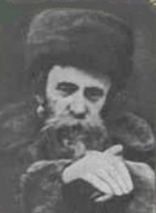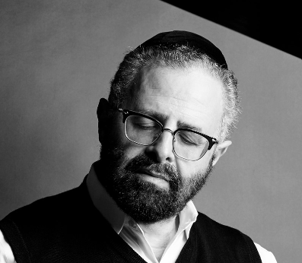
Rav Aharon of Belz and the composer Yossi Green

One summer a Chassidishe Yid from Eretz Yisroel came to America and was hosted by a family in Seagate. The following day after Shacharis he noticed one person was still in the shul. [I was told that it was the composer Reb Yossi Green.]
He went over to him and said, I am here for a few months in order to visit some doctors and then I am to have a procedure. I would greatly appreciate if you would be willing to be my chavrusa every day during these few months, for whatever amount of time that you can.

The Chavrusa Learning Went Smoothly
Reb Yossi himself was thinking about learning extra in the summer as his family was upstate, so he replied yes. The guest wasn't particular on what to learn, and whatever Reb Yossi wanted to learn was good for him and it went smoothly.
On the afternoon of chof Av or perhaps later on, in the evening, his chavrusa said, tomorrow is the yahrzeit of my Rebbe the heilike tzaddik, Reb Aharon of Belz, and I had the tremendous zechus (merit) to be one of his attendants for a period of time. My custom is that I prepare a small seudah on the day of his yahrzeit and learn some mishnayous in the Rebbe's memory, but I need a minyan.
Yossi, I don't know the people here, can you please arrange that a minyan remains after shacharis. I see that almost everyone leaves immediately after davenning. Of course, I will pay for the seudah and he gave him money to purchase the necessary items.
Reb Yossi had to call much more than ten people, until he received assurances from another eight that they will attend.
However, after davening only seven of them were present, while Yossi and the guest made it nine, and they were missing one for the minyan.
The man pleaded. can one more Yid be found that we would have a minyan, and while they called many numbers, no one was locally around to attend.

Yossi’s Father Agrees to Drive Over to Make the Tenth Man
Suddenly, Yossi said I will call my father, maybe he can come. His father heard the situation and said although I am almost an hour away from Seagate, if the people would remain, I will drive over.
When he arrived, they began the seuda and then the Yid said, I will relate a story that I personally witnessed in the period of time that I was zoche (merited) to be an attendant by the Rebbe.
He then related; there was a man who was married for many years and was not blessed with a child. Each year when he had come to the Rebbe, [author’s note: I believe the person speaking noted that it was motzei Yom Kippur] the Rebbe blessed him that Hashem will definitely help, however, the brocha had not yet come to fruition.
One year he decided that he would not move from the Rebbe’s presence until the Rebbe guarantees him that he will be blessed with a child. When he came to the Rebbe and the Rebbe said, Hashem will help, he poured out his heart and then said, Rebbe, I am remaining here until the Rebbe guarantees that we will be blessed with a child.

The Rebbe Says “You Will
Merit to Have a Son This Year”
The Rebbe heard his pain and anguish and concentrated deeply for a few moments. He then said You will merit to have a son this year.
Hearing these words from the Rebbe, the Yid answered Amen and began walking joyfully home. But before he was able to take a few steps, a chashuvah Yid said to him, I want to be the sandek at the bris.
The Yid was in seventh heaven and he happily replied, Yes.
As the Rebbe promised that Yid had a son and the Yid also kept his word.

Yossi Became Concerned
About His Father’s Pale Face
Throughout the story everyone present was enraptured by the way this Yid became so alive when he was saying the story, they felt they were witnessing the person reliving it, that they weren't paying attention to anything else. When the story ended, Yossi looked at his father and became startled.
His father was no longer wearing his hat, his face was pale and he was sweating profusely, while he was dabbing it with napkins to remove the sweat.
Tatte, are you OK. Should we call the Hatzalah, he cried out nervously?
Yossi, Boruch Hashem I am OK. Please give me some water, everything is good.

A Most Shocking Revelation
After drinking more than one cup water and wiping the sweat of his brow, Mr. Green began speaking in a choked voice. And what he said shocked everyone.
Yossi, my son, the story this man said is true in every detail. The man in the story was me and you my dear son is the son that the Heilike Rebbe, Reb Aharon may his merit protect us, blessed us with.

Reprinted from the Parshas Shoftim 5784 email of Rabbi Sholom DovBer Avtzon’s Weekly Story.

The Measly Penny

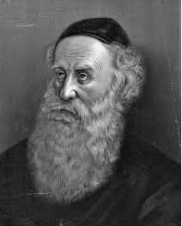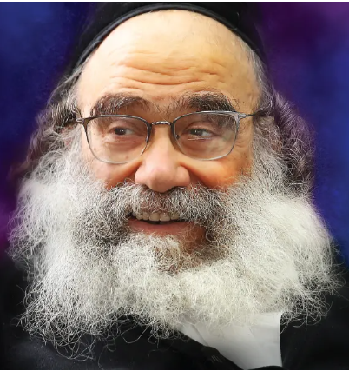
The Ba’al HaTanya and Rav Gamliel Rabinowitz

Rav Gamliel Rabinowitz related a story. One time, HaRav Ba’al HaTanya, zt”l, went to raise funds to redeem a captive, as the students of the Ba’al Shem Tov would do. In those days, many people in need of a livelihood would rent a tavern from the village owners who were very brutal, and if the tavern owner did not have enough money to pay the rent, the wicked landlord would throw him into a narrow pit. It would become a matter of Pikuach Nefesh, as the landlord would not release the prisoner until the debt was paid.
The Ba’al HaTanya came to a certain town and wanted to see the wealthiest people, and he received a list of the honorable people which Hashem had bentched with wealth. Amongst those on the list was a very wealthy man, but as great as his wealth was, his stinginess was equally as great. It did not matter the cause, he would never give more than a measly penny to anyone who asked him for money.
The Ba’al HaTanya was told not to even bother to knock on his door, because aside from the embarrassment, nothing would come of it. However, the Ba’al HaTanya specifically chose to go to this Jewish man anyway, and explained the situation to him, that presently there was a Jew in a pit whose life was hanging in the balance, and it was up to them to save him.
The wealthy man listened, and took out a small coin and gave it to Rav. The Ba’al HaTanya did not flinch, and he took the coin from him with great pleasure and bentched him for the donation, and turned to leave. As he was going down the stairs from the house, he heard the wealthy man call him back. The Ba’al HaTanya returned, and the wealthy man took out another small coin, worth a little more than the first coin, and gave it to the Rav, and again the Ba’al HaTanya bentched him profusely, and started to leave.
The man once again asked the Rav to return and gave him slightly more than previously. This went on over and over until the wealthy man was giving sizable amounts. Finally, the man opened his drawer that was full of money and said, “Rebbe, please take whatever you need.”

The Closed Heart of the Wealthy Man was Opened
The Rav took the amount he required, and warmly bentched him for the Mitzvah that he merited to perform, and from then on, the closed heart of the wealthy man was opened, and he began to give much tzedakah.
The Ba’al HaTanya later explained, “The wealthy man was so stingy because when a poor man once came for a donation, the man gave a small amount, and the poor man became angry and rebuked him and did not want to take the donation. This caused his heart to close to the mitzvah of tzedakah. When I thanked him for whatever he gave me, no matter how small, it caused his heart to be moved until it opened completely as is befitting a Jewish heart.”
Rav Gamliel teaches from this that soft words will appeal to a person, while harsh words will force a person to become closed up, and when dealing with others, the correct and proper approach that one should take is to use soft words and always have a nice demeanor!

Reprinted from the Parshas Shoftim 5784 email of Rabbi Yehuda Winzelberg’s Torah U’Tefilah.

The Chofetz Chaim
and the Pharmacist

The Chofetz Chaim, Rav Yisrael Meir Kagan, once stopped by a pharmacy and told the pharmacist how much he envied him. The man was taken aback, and asked what there was to envy?
The Chofetz Chaim explained he envied the pharmacist because of his many opportunities in the course of each day to sell medicines and save lives.
The pharmacist responded that he merely did it to make a living, not out of any other motives.
Hearing that, the Chofetz Chaim said to him, “When you come to work, you must have the intention that ‘I am coming to fulfill a Mitzvah of Chesed to others and saving lives.’ The profit-making side of it does not devalue the Mitzvah, as long as you have the proper intention!”
The pharmacist followed the Chofetz Chaim's advice, and over time, the pharmacist, who until then had been somewhat distant from his faith, became fully observant, and eventually, he rose to become the head of the Chesed organizations in his city! (Kuntres Chaim V'Chesed)

**********************************************************
Just Be YOU!
Rav Naftali Amsterdam was a Talmid of Rav Yisroel Salanter. He once came to his Rebbe and said, “Rebbi, if I had the head of the Shaagas Aryeh, and if I had the Neshamah of the author of the Yesod V’Shoresh Ha’Avodah and if I had your good Middos, then I could truly be a Servant of Hashem.”
Rav Yisroel Salanter responded to him, “Naftali, with your head, and with your heart, and with your good personality traits, you can be Naftali Amsterdam! That is all you have to be. You do not need to be the Shaagas Aryeh, or Rav Yisroel Salanter, or anybody else. Just be YOU, and that is how you will serve Hashem!”

Honoring the Torah Itself!

Rav Aharon Kotler, zt”l, the Rosh Yeshivah of Lakewood, was preparing to travel to Eretz Yisroel for a visit. His Talmidim made preparations to accompany him and escort him to the airport, but when Rav Aharon found out about their plans, he told them that he preferred they remain in the Yeshivah and continue their learning.
The Talmidim were in a quandary about what to do because they loved their Rebbe and wished to see him off, but they did not want to upset him by not following his wishes. They decided to ask Rav Moshe Feinstein, zt”l, for advice. Rav Moshe considered the question and answered, “Accompany the Rosh Yeshivah to the airport. Honoring Rav Aharon is like honoring the Torah itself!”

Reprinted from the Parshas Shoftim 5784 email of Rabbi Yehuda Winzelberg’s Torah U’Tefilah.
The Two Kopecks
By R’ Yoni Schwartz

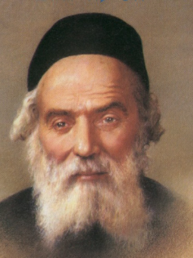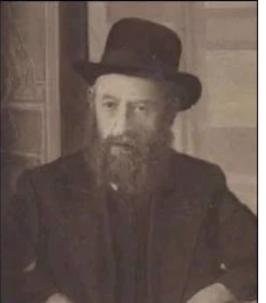
The Chofetz Chaim and the Rebbe Rashab of blessed memories

Decades ago, in the times of the Chofetz Chaim, ZT”L, there was a terrible decree against the Jews in Russia. As a result, the gedolei hador decided to hold a large convention in St. Petersburg to discuss the pressing issue. At some point during the convention, a very interesting dialogue took place between the Lubavitcher Rebbe at that time, the Rebbe Rashab, and the Chofetz Chaim. The Chofetz Chaim had to write a certain letter. However, there was just one issue: he didn’t have any paper.
He saw that the Rebbe Rashab had some extra paper and decided to ask him for a sheet. The Rebbe happily gave him one. Afterwards, the Chofetz Chaim handed the Rebbe Rashab two kopecks, which are coins of very small value, but enough to cover the cost of that one piece of paper. A bewildered bystander approached the Chofetz Chaim and said, “You know the Rebbe has plenty of paper and plenty of wealthy people providing his stationery needs. Those two coins don’t mean anything to him. Why are you giving them?
The Chofetz Chaim’s response was legendary. He said, “To me the two kopecks also aren’t worth anything but two kopecks of geneiva (stealing), that's worth billions. That can create one malach (angel) that can turn over all of St. Petersburg with one blow!”

Reprinted from the Parshas Shoftim 5784 email of Torah Sweets.

